Rebecca Leu

Northeastern University

Introduction to Enterprise Analytics

Emergency Facilities Readiness project

Introduction – Estimation and Simulation

The Emergency Facilities Readiness Project is a demonstration of estimation and simulation practices in data analysis. Parameters for total number of victims, distributions of those victims, transport time and distributions of the transport time for each hospital are given. With the given data and project instructions we will be evaluating the readiness of local emergency facilities. Each analysis conducted, with different parameters given, is simulated 5,000 times to determine the most accurate forecast for the emergency. We will determine what each of the average transportation times result in different probability distributions of their own.

Analysis

**Part 1**

To begin we are given that the total number of victims is approximated by a triangular distribution and how the five hospitals will distribute the victims by percentage. The 5000 simulations begin with the distribution of the total number of victims under the triangular distribution. To do this, nested IF statements are used in excel to create the appropriate triangular distribution putting limits on the peak of the victims at 80 and the minimum at 20 and maximum at 300. After this is completed each hospital is given a proportion of those victims which is calculated by multiplying the proportion by the random victim count for each of the 5000 simulations. The average number of victims for each hospital are as follows:

|  |  |
| --- | --- |
| Beth Israel Medical | 11 |
| Tufts Medical | 8 |
| Massachusetts General | 16 |
| Boston Medical | 13 |
| Brigham and Women’s | 5 |

The average number of victims that can be expected at each hospital reaches a limit after several simulations resulting in an average. The law of large numbers is demonstrated here for Beth Israel Medical.

The law of large numbers assumes that with many trials the average number begins to appear as it does here around 25. Had we only used maybe 100 values, we may not have gotten as much of an accurate average.

Continuing with our calculations we calculate the total transport time for each hospital and calculate the average total time in hours needed to transport all the victims.

|  |  |
| --- | --- |
| Beth Israel Medical | 6.4 hours |
| Tufts Medical | 3.3 hours |
| Massachusetts General | 4.5 hours |
| Boston Medical | 8.8 hours |
| Brigham and Women’s | 4.4 hours |

Following this calculation, we take a deeper dive and perform an exploratory data analysis for the Beth Israel medical hospital. We calculate a 95% confidence interval of the total transport time to be between 5.94-6.34 minutes. A frequency distribution of the transport time is shown.

This histogram tells us the data appears to have an exponential distribution. By preforming a chi-test we find that the data does follow this distribution.

After preforming the exploratory data analysis for Beth Israel total travel time, we complete the same analysis for the total travel time of all hospitals in minutes per victim. Our 95% confidence interval is between 12.38 and 12.71 minutes per victim. Viewing a histogram of the data it data to be distributed lognormally.

**Part 2**

Continuing the same calculations as previous, we look at the data given alternative variables. Instead of the victims being triangularly distributed, this analysis begins with the victims normally distributed with a mean of 150 victims and a standard deviation of 50 victims given. The 5000 simulations are calculated using the random number tool and imputing the mean and standard deviation for the normal distribution. After completing this and distributing the victims to the same proportions given initially, we calculate the average number of victims per hospital.

|  |  |
| --- | --- |
| Beth Israel Medical | 30 |
| Tufts Medical | 22 |
| Massachusetts General | 45 |
| Boston Medical | 37 |
| Brigham and Women’s | 15 |

Moving forward we again calculate a law of large numbers plot showing the average victims at Beth Israel hospital appears to level out at about the 30 mark. Again, this number does not start to level off until 100 or so simulations into the process confirming that the law of large numbers provides us with the most accurate results and averages of these numbers. The more simulations that are ran, the closer we are to finding the most precise means.

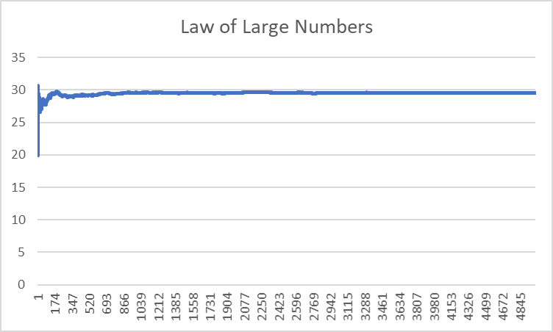

Continuing to the analysis of transport time, we determine the average total time in hours needed to transport the victims for each hospital.

|  |  |
| --- | --- |
| Beth Israel Medical | 7.5 hours |
| Tufts Medical | 3.7 hours |
| Massachusetts General | 5.3 hours |
| Boston Medical | 9.3 hours |
| Brigham and Women’s | 5 hours |

Breaking into the exploratory data analysis of Beth Israel Medical hospital we calculate the confidence interval for total transport time to be between 7.44 and 7.6 hours. The probability distribution appears to follow the normal distribution.

Again, a chi-squared goodness of fit test was completed which confirmed our analysis that the data fit into the normal distribution.

Finally, we conclude our analysis with the exploratory data analysis of t for the average total transport time in minutes per victim for the entire process of transporting all victims. This confidence interval was calculated at 1838.65 through 1875.68 minutes per victim. The histogram completed of this data also shows a normal distribution.

Conclusions

The differences between the outputs of simulations one and two were quite different. In simulation one we ended with an exponential and lognormal distributions while the second simulation calculated normal distributions. We know the reason for this difference is because of how the victim and transport time data were distributed differently in each simulation. Although the data were distributed differently, the average transport time for the individual hospital and the total amount of victims as a whole ended up being very similar. If this data were to be used for planning purposes for these hospitals, the hospitals could prepare for the most likely situations knowing how quickly they need to clear out space for victims, how many doctors and nurses should be on hand and how quickly they could get to the hospital if contacted in an emergency situation, or even trying to see if they could cut out any time during these runs to see if they are able to get to more victims in times of immediate need. The simulations distributions of victims and transport time could be changed to any number of expected values to come up with new data as times change. Perhaps transport times could be quicker when a new public transportation system is updated providing emptier streets for ambulances to use. The data could be changed for any number of reasons and be used again and again in the future. Hospitals could use this information to see what variables they can change to make the number of accepted victims climb higher and the time to get the victims decrease.